AMARO- DROM COMMUNICATION STRATEGY
2020-2024

CONTENTS

1. BACKGROUND 2
2. GUIDING PRINCIPLES 3
3. SITUATION ANALYSIS 4
3.1. External communication analysis 4
3.2. Internal communication analysis 6
4. AUDIENCE IDENTIFICATION 7
5. COMUNICATIONS OBJECTIVES 8
6. KEY MESSAGES FOR EACH AUDIENCE 13
7. COMMUNICATION CHANNELS AND ACTIVITIES 17
8. MONITORING AND EVALUATION 20

1. Background

The Union for Development and Integration of Roma Minority in Albania was established in 1996 as a non-profit Albanian membership-based organization. It works at a national level with a head office in Tirana covering all the regions of Albania.
Amaro-Drom cooperates with a variety of stakeholders to fulfil its mission in development and integration of the Roma community. Through the years ambitious objectiveshave guided the work of Amaro- Drom requiring multifaceted engagement, management abilities and a great communication with all stakeholders.
In order to guaranteein continuitysustainable and successful cooperation with our partners and main stakeholders Amaro- Drom has developed the new communication strategy 2020-2024 which will re-orientate communication in the organization. 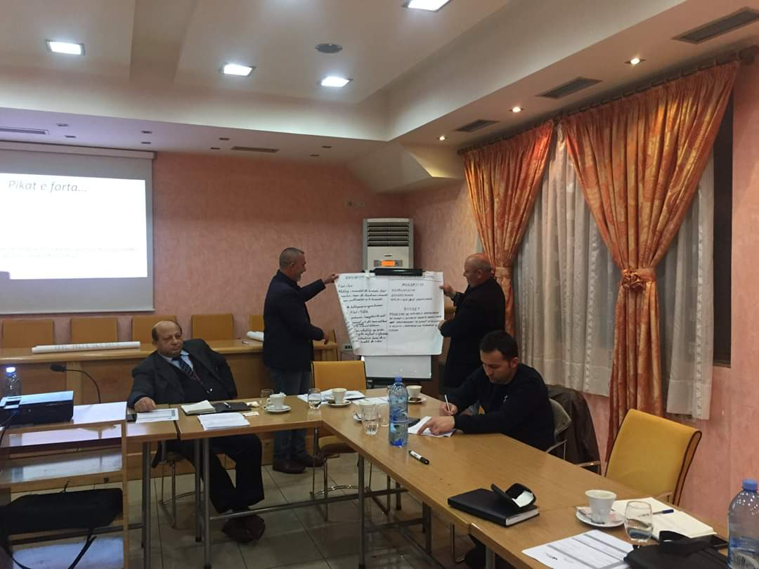
These strategy aims to:
- Improving communication with partners and other interaction systems
- Enhancing the exchange of information in the process of implementing goals and objectives
- Improving the transparency of our organization
- Creating and promoting a better image of the organization

Although Amaro- Drom has a consolidated base of communication channels, there is a need to develop an instructional model that will diversify the communication process to fit the needs of the audiences and the organization.

Guiding Principles

In support of Amaro- Drom mission, this communication strategy has the following guiding principles which will reorient work and activities
Credibility, truthiness and respect - successful communication requires trust, credibility and respect for all actors included. Our communication strategy should create the perception of truthiness in our stakeholders and mutual respect, making them confident to collaborate with us
Understanding and dialogue – our communication strategy promotes understanding through multi-faced dialogue. We are aware that audiences differentiate in their values, attitudes, needs and experiences. Without a comprehensive understanding of audiences we cannot address successfully our communication needs. Thus promoting dialogue and building connection between different actors with illumine the scene.
Results-Based – Strategic communication should be integrated in all organization mechanism, functions, and oriented in obtaining specified results that adhere to its vision, mission and objectives.
Partnership – Amaro- Drom believes that a good communication strategy requires cooperation between all actors involved in facilitating communication exchange. Partnership is important in implementing plans and activities

Situation analysis

External communication analysis

Amaro- Drom communicates with different stakeholders. These communications attempt to support Roma initiatives, and change perceptions, attitudes in supporting Roma community rights and the fulfilment of their fundamental freedoms.Accomplishing the mission of our organization requires a serious commitment and cooperation between all actors.Of course, these cannot be achieved without a productive communication between all stakeholders and the appropriate choose of the communication channels.

Communication with Roma community members
Cooperating with Roma community has required a great effort in maintaining a sustainable relationship. A considerable number of members of the Roma community lack trust in institutions, as well as in non-profit organizations.Ensuring a strong connection with the Roma community reinforces the position of Amaro- Drom and increases the representation of community concerns and interests at decision-making level.

In order to secure a successful cooperation with Roma community, creating a better image of organization and perception of Amaro- Drom organization as trustworthy is a critical part. The promotion of our organization, and the work for improving the well-being of the Roma community addressing various needs such as housing, employment, education and health concerns, requires appropriate communication channels. These communication channels should take into account the characteristics of Roma community. Most of them live in poor conditions, have low level of education, and don’t have access on internet or other useful resources for communication.

Communication with central government actors and policy- maker
Central government actors and policy maker have decisive power in drafting and implementing policies that affect wellbeing of the Roma community. National Strategies and Action Plansoutlines a series of activities to improve the lives of the Roma community, based on a current situation analysis and identified needs. An important part of the identification of the Roma community needs are consultations and round tables with different stakeholders. Line ministries have set minimal standards and procedures for public consultations. Some of the mechanisms include online publications of policies and strategies, open calls for recommendations from stakeholders; and organizing consultative meetings.Our communication with central government actors and policy makers should be focus on creating as many as much possibilities for participating in those consultations and round tables, which would help us to provide our recommendations regarding Roma community needs and shaping policy decisions.

Communicationswithlocal partners
Local authoritiesinclude local government actors, schools, employment offices, and health centres. These authorities play an important role in fulfilling our organization mission. We
are constantly interested in collaborating with them for various initiatives addressing employment, housing, education and health issues in the Roma Community. However,these collaborations are not always sustainable, most of them are only when required, and then everyone works on their own.Local government authorities and Amaro- Drom often serve to the same client, so exchanging information and continuous communication would be in beneficial for both parties. These information should be timely, accurate, and provided within appropriate context.
Communicationwith donors
There is a number of donors with great interest to the Roma community including EU; OFSA; UN; AIDS; Swiss Agency for Development and Cooperation; Roma Education Fund; USAID etc.Amaro- Drom has had successful cooperation with some local missions of international organizations. However, attracting as many donors and supporters as possible to our projects remains a challenge, as long as our financial capabilities are limited. Donors tends to support organizations which communicates better and show credibility in their communications. Transparency, and updated information are essential in maintaining relations with existing donors and at the same time attracting new donors.

Communication with Partners organizations
Amaro- Drom is part of a network organizations which work with the Roma community. We cooperate and exchange information with each other regarding different issues in relation to Roma community.Amaro- Drom should ensure appropriate, clear and timely information is available to those who request the information. In certain cases we organize meetings to issue recommendations and address it to public institutions. Our communication strategy should take into account different alternatives for adequate information exchange with partners. Furthermore,communication with partner organizations should also aim to inform them about our capacity to share expertise and knowledge regarding issues of common interests.

Internal communication analysis

Internal communication is a vital aspect that not only improve organization climate, but also contribute in overall organization performance. Strategic communication within an organization needsleadership that emphasizes the importance of communication and appropriate channels of communication with staff.
Communication within Amaro- Dromstaff
In order to support communication betweenleadership on different hierarchal positions, and Amaro- Drom staff, an organized schedule which predict regular staff meetings should be adjusted. Employee should be regularly informed about future plans of the organization. They should be given the opportunity to express their opinion on different initiatives. Furthermore, updated strategic vision, mission,budget implications, logo, symbols or other official materials should be addressed and communicate to staff. Staff should be informed, updated, feel connected and engaged in the organization mission. In addition, staff should feel secure and see Amaro – Drom as an organization that cares about their social-emotional needs.

Audience identification

Amaro-Drom has a wide collaboration with a range of actors. In this communication strategy the main audiences will include: the Roma community; central government actors/ policy-maker, donors; local government actors;partners organizations, and Amaro-Drom staff. These groups are important to achieve the mission and objectives of Amaro-Drom. Audiences’ identification has followed a process of consulting with staff, initially identifying a broad list of stakeholders and then reducing them to key interest groups for Amaro-Drom. Below is a list of audiences their interests
AUDIENCES |  | INTERESTS
Roma community |  | Employment, housing, support for their culture and identity, improvement of life conditions; wellbeing; sustainable support
Government actors/ policy- maker |  | Cooperation for fulfilling strategic objectives of national strategic plan for Roma community; evidence based information regarding Roma situation
Local government actors | actors from municipality and administrative units | Cooperation for activities which promote community welfare; social and economic development; improvement of infrastructure and living conditions; evidence based information
 | employment offices | Cooperation for employment, information and counseling
 | Schools | Quality education, inclusiveness, low level of school drop-out
 | Health centers | Providing quality, continuous, integrated and accessible healthcare to all
Donors |  | Fulfillment of conditions and requirements for donations made; transparency and credibility
Partner organizations |  | Cooperation on issues of common interest; expertise

Communication objectives
External communications objective
COMMUNICATION OBJECTIVE 1

Target audience: Roma community
Objectives
- To ensure that the Roma community members are well-informed about our mission and initiatives to support them.
- To ensure that Roma community members perceive Amaro- Drom as trustworthy
Expected result:
- Increased knowledge regarding Amaro- Drom mission and its initiatives.
- The Roma community memberstrust Amaro-Drom and believe in its initiatives
Duration: in continuity
COMMUNICATION OBJECTIVE 2

Target audience: Policy-makers/ actors from government
Objective:
- Influencing policy-maker to consider us as a key stakeholder in their calls for cooperation regarding drafting and implementing policies for Roma community
- Influencing policy- maker to perceive us as credible and trustworthy
Expected result:
- Policy-makers calls and give us priority in their consultations regarding Roma community
- Policy- makers consider us credible and trustworthy
Duration: In continuity
COMMUNICATION OBJECTIVE 3

Target audience: actors from municipality and administrative units
Objective:
- To ensure that actors from municipality and administrative units trust in our capacity to help in Roma initiatives
- To ensure actors from municipality and administrative unitsconsults with us regarding development of local action plans.
Expected result:
- Actors from municipality and administrative units involve us in their initiatives
- Actors from municipality and administrative units constantly consult with us
Duration: In continuity
COMMUNICATION OBJECTIVE 4

Target audience: Employment offices
Objective:
- To inform them about our initiatives in assisting Roma community members for employment
- Influencing employment offices to constantly communicate with us for the employment of members of the Roma community.

Expected results:
- Increased knowledge regarding Amaro- Drom initiatives
- Successful information exchange between employment offices and Amaro- Drom
Duration: In continuity
COMMUNICATION OBJECTIVE 5
Target audience: school

Target audience: Schools

Objective:
- To raise schools awareness regarding Amaro- Drom’ initiatives for integration and inclusiveness of the Roma children
- To influence schools to consider Amaro- Drom as a key partner regarding education and inclusion of the Roma children
Expected results:
- Schools are aware regarding Amaro- Drom initiatives for integration and inclusiveness of the Roma children
- Schools constantly communicate and cooperatewith Amaro-Drom regarding education and inclusion of the Roma children
Duration: In continuity
COMMUNICATION OBJECTIVE 6

Target audience: health centres
Objective:
- To inform health centres about our initiatives in supporting Roma community members to adequately access health centres.
- To encourage the two way communication with health centres regarding Roma community sensitive health issues.
Expected result:
- Increased knowledge of health centres regarding Amaro- Drom initiatives
- constant communication with health centres regarding Roma community sensitive health issues
Duration:In continuity
COMMUNICATION OBJECTIVE 7

Target audience: Donors
Objective:
- To ensure that donors perceive us as credible and trustworthy organization
- To better inform them regarding our impact in Roma community
Expected result:
- Donors trust us in support of the Roma issue
- Increased knowledge regarding our impact in the Roma community
Duration: in continuity
COMMUNICATION OBJECTIVE 8

Target audience: Partner organizations
Objective:
- To influence partner organizations in improving two way communication on issues of common interests
- To influence partner organizations in perceiving us as an organization which provides expertise and great experience in issues of common interests
Expected result:
- constant and improved communication
- Increased sharing expertise and experiences with partner organizations
Duration: In continuity.

Internal communication objectives

Key messages for each audience
Key messages for Roma community members
We collaborate with key institutions to assist Roma families in employment, education, housing and health care.

Amaro-Drom supports and empowers Roma families to meet basic needs.

Amaro-Drom offers opportunities to increase the welfare of the Roma families through education and information
We encourage and preserve Roma ethnic values in every initiative

Key messages for government or policy maker
Amaro-Drom offers alternatives for integration of the Roma community through experience, day-to-day work with Roma familiesand data collection over years.

Amaro-Drom meets its responsibilities and provides a sustainable cooperation for implementation of the action plans
We provide you with evidence- based information regarding Roma community

Key messages for municipality and administrative units
Amaro-Drom expresses its full commitment to cooperate for the well-being of the Roma community.
Amaro- Drom provides information, statistics and fieldwork to assist in compiling evidence-based local action plans on the integration of the Roma community.

Amaro- Drom facilitates your work by informing and assisting the Roma community members in preparing the necessary documentations for economic assistance and social housing.

Key messages for employment offices
Amaro - Drom offers assistance to the Roma community members in registering in the employment offices, filling in and preparing the necessary documents
Constant communication and collaboration with Amaro- Dromfacilitate the Roma employment process.

Key messages for schools
Amaro-Dromeducates, informs and increase awareness in schools on the integration of the Roma community.

Amaro-Drom is open to collaborations in developing open lectures with pupils

Amaro-Drom facilitates your work with Roma community children by providing assistance in registering and promoting regular school attendance.

Key messages for health centres
We are ready to help you in communication with the Roma community on sensitive health issues
We are open to collaborate in order to create adequate access of the Roma community in health care services

Key messages for partners
Amaro- Drom provides opportunities to share experiences and expertise with other organizations
Amaro- Drom offers opportunities for successful and effective cooperation on issues of common interest

Key messages for Donors
Cooperation with Amaro-Drom further advances the development of Roma community, through guaranteeing better coverage with services for Roma families in rural and urban areas.
Amaro-Drom offers the opportunity for an efficient, effective and transparent use of funds in support of the Roma community.

Communication channels and activities

Audience | Communication Channels | Activities
Roma Community | - face to face meetings with local community  - Visual instruments (photos, videos)  - Printed materials (posters)  - Testimonials  - Home visits | -Organizing face to face meetings with the Roma community  -Using visual instruments to present our mission and initiatives in providing support for the Roma community members  -Using testimonials to communicate trustworthiness in our organization  -Organizing home visits in Roma community families to discus with them in a more familiar place
Policy-makers | - Round table meetings and consultations  - Website  - Event  - Email | -Participating in round tables and consultations to exchange information, building knowledge and contributing to evidence based policies  -Using and updating website in order to promote our work, highlight success stories, and provide necessary information to increase credibility of our organization  -organizing events with beneficiary to present policy-maker and actors from government with our achievements for integration of the Roma community  -Using email to exchange information regarding Roma community situation
Actors from Municipality and Administrative Units | - Round table meetings and consultations  - Online network  - Website  - Event  - Printed material (leaflet)  - Email | -Using round table meetings and consultation to exchange information; propose alternatives for integration of the Roma community in their local action plans  -Using online network for proactive and constant communication in supporting Roma community members  -Using events to promote our work and capacity to offer real help for Roma community  - Using leaflet to inform staff of administrative units on our mission and things which we can cooperate together  -Using email to communicate relevant information
Employment offices | - Face to face meetings  - Printed material (leaflet and brochures)  - website  - Email  - Mobile communication | -usingface to face meetings to inform employment offices about our mission and our willing to cooperate  -Using leaflet and brochures to provide them with a basic written information about our mission and our success initiatives which are of common interests  -Using website to promote our work and cooperation with employment offices  -Using email and mobile communication to communicate and exchange necessary information regarding employment
Schools | - Face to face meetings  - Focus groups  - Mobile communication  - Social media  - Printed materials | -Using face to face meeting with school leaders to inform them about our mission and initiatives  -Using focus groups to discuss problems or difficulties with school staff regarding inclusiveness of the Roma children  -Using mobile communication for faster information exchange; concern issues  -Using social media to present and promote our projects with schools  -Using leaflet to inform schools about our activities and success initiatives which are of common interests
Health centres | - Face to face meetings  - Printed material (leaflet and brochures)  - Mobile communication | -face to face meetings with health providers to inform them about our initiatives and the willing to cooperate with them  -Using printed materials to expose our work  -Using mobile communication for initiatives regarding Roma community
Donors | - Conferences  - website  - Email  - Annual reports | -Participating in national and international conferences dedicated to Roma community in order to attract donors and present our organization  -Using website to promote our work, to provide updated information of our activities and initiatives (written and visual)  -Using email to communicate sensible information with donors, propose project and strategies  -Using annual reports to make our work transparent
Partner organizations | - Website,  - email,  - consultations  - round tables,  - group meetings | -Using website to promote our work, attract partner organizations for sustainable cooperation.  -using email to communicate regarding issues of common interestsand updating partners on prospective projects  -Participating on consultations to share information and exchange experiences with partner organization  -Participating and organizing round tables with partner organizations to discuss on issues of common interests  -Participating and organizing group meetings for brainstorming, relationship building, building trust and loyalty with partner organizations.

8. Monitoring and evaluation

Implementation of communication strategy requires a good process of monitoring and evaluation. Implementation of the communication plan will be continuously monitored and evaluated. For each communication objective a specific plan will be implemented. Continuousreporting will be required for each staff member responsible for the implementation of the plan. Responsible for monitoring will be Amaro-Drom leaders, and coordinator who will ensure that activities are fulfilled based on vision, mission, goals and objectives set. Fulfilment or not of the objective and expected result, will provide critical information on the feasibility of the plan and the integration of communication strategy across all sectors and levels of Amaro-Drom. For this reason it is important to have a periodic situation report every 6 months to see the progress of communication strategy and identify potential needs for intervention and improvement. After the first year of implementation, an assessment will be carried out to see the overall progress of communication strategy.

